- Are you a member of the Armed Forces Community?

- Do you sometimes feel that no one understands you?

- Could you benefit from talking to another Veteran about your housing, health and wellbeing or transition?
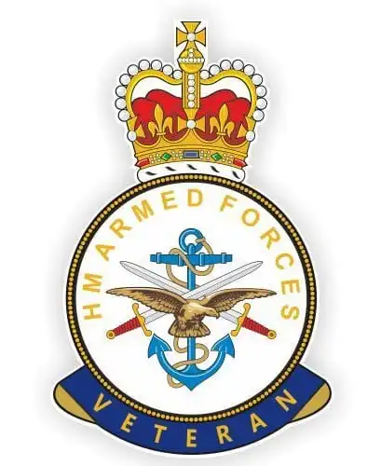
The Armed Forces Community Social Prescribing Link Worker intervention was designed to support members of the Armed Forces Community across Cornwall and The Isles Of Scilly, supporting veterans and spouses, children, widows and full time carers of a veteran, who often report as feeling under supported.
Social prescribing is an approach that connects people to activities, groups, and services in their community to meet the practical, social and emotional needs that affect their health and wellbeing.
Having served in the armed forces themselves, the Armed Forces Community Social Prescribing Link Workers have first-hand experience of the difficulties and barriers veterans can face and are therefore ideally placed to provide advice and empathy.
Contact one of the team today:
East Cornwall West Cornwall
Marc Walsh Kev Riddle
marc@activeplus.org.uk kevin@activeplus.org.uk
07903 097263 07951 959230
For more information visit our website: www.activeplus.org.uk

